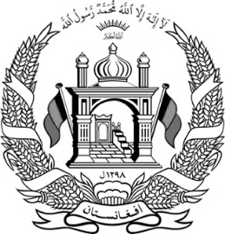 | Islamic Republic of Afghanistan  National Statistics and Information Authority  Deputy Office for Registration of Population  Births Certificate | 

This section to be filled by the health care centers or local centers for registration of births (village representative/Mosque clergy)
Information of the Newborn
Identification of the Newborn |  | Birth Indicators
Name | XXXXX | Date of birth | XXXXX
Last name | XXXXX | Place of Birth | XXXXX
Father’s name | XXXXX | Place of Birth | XXXXX
Grandfather name | XXXXX | Sex | XXXXX
Mother’s name | XXXXX | Sex | XXXXX

National Tazkera (ID) Information of Newborn’s Father
Volume No. |  |  | Page No. |  | Registry No
Electronic Tazkera (ID) Serial number |  |  |  | XXXXX
Issuing Authority |  | Health Center, Birth Statistics, Village Leader, Mosque Clergy
Signature |  |  | Date |  | Stamp

This section to be filled by National Statistics and Information Authority
Address of births registration book |  | Permanent residency of father of newborn
Office | Births | Province
Volume number | Central Office | District
Page number | XX | Sector
Registration number | XX | Village
BR database code | XXXXX

XXXXX

Director of Births Statistics Registration Services

